**AWS Budget Setup**

[**https://aws.amazon.com/console/**](https://aws.amazon.com/console/)

Go to Billing Dashboard 🡪 IAM User and Role Access to Billing Information – edit and check activate IAM access – this will allow IAM users who are administrators to access billing data. If you don’t want that you can set up the billing alarm using the root account.

Go to billing 🡪 Scroll down 🡪 charges by service 🡪 expand and see the service usage

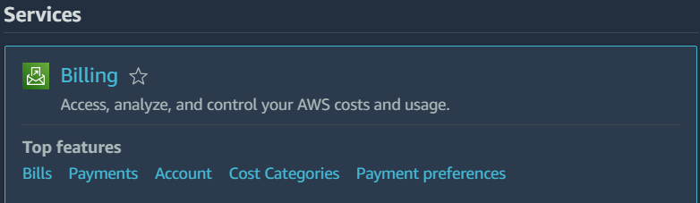

Budgets 🡪 Create budget 🡪 Budget name 🡪 email recipients

If you are creating monthly cost budget you have option to enter your budget amount ($) give the email and create.

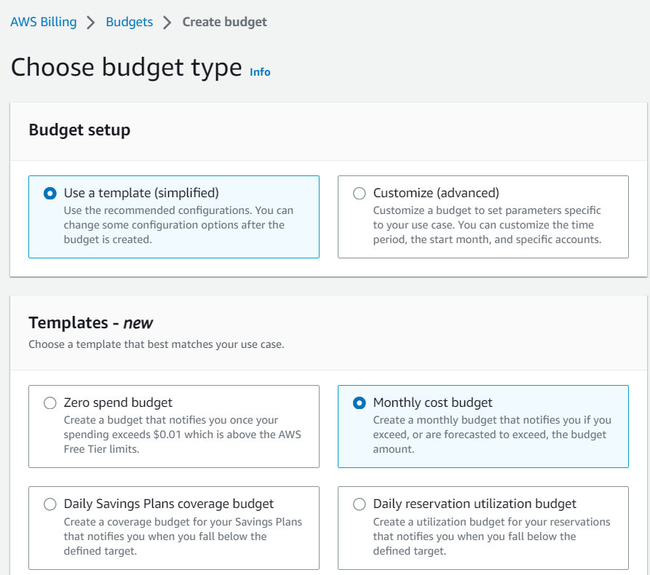

**EC2 Basics – Amazon EC2**

* EC2 is one of the most popular of AWS offering
* EC2 = Elastic Compute Cloud = Infrastructure as a Service
* It mainly consists in the capability of:
* Renting virtual machines (EC2)
* Storing data on virtual drives (EBS)
* Distributing load across machines (ELB)
* Scaling the services using an auto-scaling group (ASG)
* Knowing EC2 is fundamental to understand how the cloud works

**EC2 Sizing & Configuration**

EC2 sizing and configuration options allow you to choose the right instance type for your needs, including the operating system, CPU, RAM, storage, network, and firewall settings.

* OS: Linux, Windows, or Mac OS
* CPU & RAM
* Storage: Network-attached(EBS or EFS) or hardware(EC2 Instance Store)
* Network: Speed and public IP
* Firewall: Security groups
* Bootstrap: EC2 User Data

**EC2 User Data**

* Bootstrap your instances using a script that runs once at the instance's first start.
* Automate boot tasks such as installing updates, software, downloading files, etc.

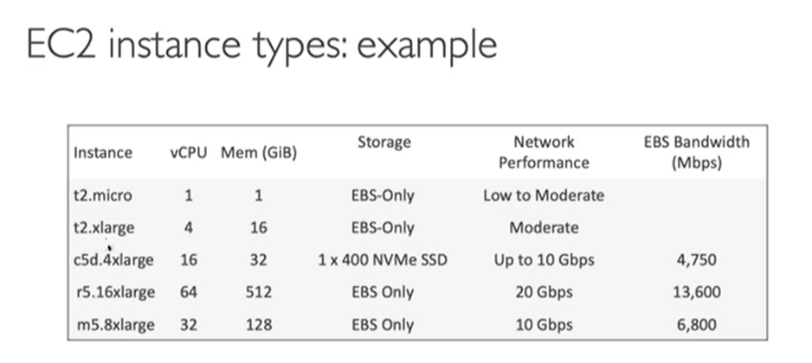

t2.micro is part of the AWS free tier (up to 750 hours per month)

* The EC2 User Data Script runs with the root user.

**Seven different types of EC2 Instances:**

1. **General Purpose:**
   * Balanced for compute, memory, and networking.
   * Ideal for web servers and code repositories.
   * Example: t2.micro instance
2. **Compute Optimized:**
   * High-performance processors for compute-intensive tasks.
   * Suited for batch processing, media transcoding, HPC, and machine learning.
3. **Memory Optimized:**
   * Fast performance for large in-memory data processing.
   * Perfect for databases, in-memory cache stores, and real-time big data processing.
4. **Accelerated Computing:**
   * Hardware accelerators for tasks like graphics processing and data pattern matching.
5. **Storage Optimized:**
   * Designed for storage-intensive tasks with high data throughput.
   * Ideal for OLTP, databases, data warehousing, and distributed file systems.
6. **Instance Features:**
   * EC2 instances offer additional features for deployment, management, and scaling of applications.
7. **Measuring Performance:**
   * Provision various instance types to find the right fit for your applications and validate your architecture.

m5.2xlarge

m: instance class, 5: generation (AWS improves them over time), 2xlarge: size within the instance class

**Security Groups**

* Security groups are essential for securing your AWS environment.
* Security groups control all incoming and outgoing traffic to your EC2 instances.
* You can create multiple security groups and attach them to different instances or groups of instances.
* Security groups are locked down to a specific region and VPC.
* All inbound traffic is blocked by default, so you must explicitly allow traffic to reach your instances.
* All outbound traffic is authorized by default, so you can restrict outbound traffic as needed.
* It is good practice to maintain a separate security group for SSH access.

**Classic Ports to know**

|  |  |  |  |
| --- | --- | --- | --- |
| **Port** | **Protocol** | **Transport** | **Description** |
| 22 | SSH | TCP | Used to remotely log into a Linux or macOS device. |
| 21 | FTP | TCP | Used to transfer files between two devices. |
| 22 | SFTP | TCP | A secure version of FTP that uses SSH to encrypt the data transfer. |
| 80 | HTTP | TCP | Transfer web pages and other resources over the internet. |
| 443 | HTTPS | TCP | An encrypted version of HTTP that is used to protect sensitive data, such as login credentials and credit card numbers. |
| 3389 | RDP | TCP | Used to remotely control a Windows device. |

**EC2 Instance Connect**

* EC2 Instance Connect is a convenient way to connect to your EC2 instance without having to use a key file.
* It is only supported for Amazon Linux 2 instances.
* You need to make sure that port 22 is open on your instance.

To use EC2 Instance Connect, simply open the Amazon EC2 console and select the instance you want to connect to. Then, click on the "Connect" button and select "EC2 Instance Connect". You will then be able to connect to your instance using your web browser.

**EC2 Instances Purchasing Options:**

* **On-Demand Instances:** Pay by the second, good for short workloads or predictable pricing.
* **Reserved Instances:** Pay for a reserved instance for 1 or 3 years to get a discount on your EC2 costs. Good for long workloads.
* **Convertible Reserved Instances:** Similar to Reserved Instances, but you can convert them to other instance types if needed. Good for long workloads with flexible instance requirements.
* **Savings Plans:** Commit to a certain amount of EC2 usage for 1 or 3 years to get a discount. Good for long workloads.
* **Spot Instances:** Bid on unused EC2 capacity to get the lowest possible price. Good for short workloads or workloads that can be interrupted.
* **Dedicated Hosts:** Rent an entire physical server for your EC2 instances. Gives you the most control over your instance placement.
* **Dedicated Instances**: Run your EC2 instances on single-tenant hardware. No other customers will share your hardware.
* **Capacity Reservations:** Reserve capacity in a specific Availability Zone for any duration. Ensures that you have the capacity you need when you need it.

Choose the EC2 instance purchasing option that best meets your needs and budget.

Consider the length of your workload, your need for flexibility, and your tolerance for interruptions when choosing a purchasing option.

If you are not sure which purchasing option is right for you, contact AWS support for assistance.

**EC2 On Demand**

EC2 On Demand is the most flexible pricing option, but it is also the most expensive. It is recommended for workloads that are short-term, unpredictable, or un-interrupted.

**Example:** A company that needs to run a test environment or a development environment would be a good candidate for On-Demand instances. This is because On-Demand instances offer the most flexibility and can be used without any upfront commitment.

**EC2 Reserved Instances**

EC2 Reserved Instances offer a significant discount compared to On-Demand pricing, but they require a 1- or 3-year commitment. They are recommended for steady-state usage applications, such as databases.

Example: A company that needs to run a production workload that is predictable and steady-state would be a good candidate for Reserved Instances. This is because Reserved Instances can offer significant discounts on On-Demand pricing.

**Convertible Reserved Instance**

Convertible Reserved Instances offer the flexibility to change your instance configuration, while still providing a significant discount compared to On-Demand pricing.

**Note:** Convertible Reserved Instances cannot be sold in the Reserved Instance Marketplace.

**EC2 Savings Plans**

EC2 Savings Plans offer a significant discount on your EC2 usage, but they require a commitment to a certain level of usage for 1 or 3 years. They are recommended for workloads that are predictable and steady-state.

**Example:** You commit to spending $10/hour on EC2 Savings Plans in the us-east-1 region for 1 year. You will get a discount of up to 72% on your EC2 usage in that region, regardless of the instance type, size, OS, or tenancy. If you use more than $10/hour of EC2 instances in that region, the excess usage will be billed at the On-Demand price.

**EC2 Spot Instances**

EC2 Spot Instances are the most cost-efficient instances in AWS, but they can be terminated at any time. They are suitable for fault-tolerant workloads that can be interrupted.  
  
**Note:** EC2 Spot Instances are not suitable for critical jobs or databases.  
  
Example: A company that needs to run a batch job that can be interrupted would be a good candidate for Spot Instances. This is because Spot Instances can offer significant discounts on On-Demand pricing, but they can be terminated at any time if the spot price exceeds your maximum bid.

**EC2 Dedicated Hosts**

EC2 Dedicated Hosts are the most expensive EC2 instance type, but they offer the most control and flexibility. They are a good choice for companies with complex licensing requirements or compliance needs.

**Example:** A company that needs to run a software application that requires a per-socket license would need to use an EC2 Dedicated Host. This is because EC2 Dedicated Hosts are the only EC2 instance type that guarantees that all of the cores on a physical server will be available to your application.

**EC2 Dedicated Instances**

EC2 Dedicated Instances are a good option for workloads that require dedicated hardware but do not require the level of control and flexibility offered by EC2 Dedicated Hosts.  
  
**Example:** A company that needs to run a production workload that requires dedicated hardware but does not need to use specific hardware for licensing or compliance reasons would be a good candidate for EC2 Dedicated Instances.

**EC2 Capacity Reservations**   
  
EC2 Capacity Reservations are a way to ensure that you have access to EC2 capacity in a specific AZ, without having to commit to a long-term contract or pay upfront fees. They are a good option for short-term, uninterrupted workloads that need to be in a specific AZ.

**Example:** A company that needs to run a batch job that needs to be executed in a specific AZ would be a good candidate for EC2 Capacity Reservations. This is because EC2 Capacity Reservations can ensure that the company has access to the EC2 capacity it needs in the specific AZ, without having to commit to a long-term contract or pay upfront fees.

**Which option is right for you?**

It depends on your needs and workload.

If you need flexibility and don't mind paying the full price, then On-Demand is a good option.

If you can plan ahead and commit to a long-term contract, then Reserved Instances or Savings Plans can offer significant discounts.

Spot Instances are a good option for fault-tolerant workloads that can be interrupted.

Dedicated Hosts are a good option for workloads that require dedicated hardware or that have complicated licensing models.

Capacity Reservations are a good option for short-term, uninterrupted workloads that need to be in a specific AZ.